Aws questions-

Types of Cloud Services-

1. IaaS- Infrastructure as a service- The client have full access to control the infrastructure. It is same as the traditional data center without physically maintaining/ managing the servers. Clients can access the servers and db but virtually.

Thing to be maintained by client- Application, runtime, middleware, data, OS

Things to be maintained by cloud provider- Networking, servers, storage, hard drives, virtualization.

Advantages- very flexible

* Pay as you use
* Highly scalable
* Client has complete control over the infrastructure.

1. PaaS- Platform as a Service- The client is provided with the software and hardware and it is managed by the provider while the client is only concerned about the application and data.

It is idle for developers. All the servers, networking, OS, runtime are maintained by the provider/third party provider.

Advantages-

* Simple and cost effective development ans deployment principle
* Scalable
* Highly available
* Reduced amount of coding needed

1. SaaS- Software as a service- The software hardware as well as the application is maintained by 3rd party itself. No need to download or install anything on client side. Everything is readily available on internet.

Advantages-

* Managed from central location
* Hosted on remote server
* Accessible over internet
* User is not responsible for hardware and software.

3 Basic types of cloud services-

1. Compute- Ec2, lambda, autoscaling
2. Storage- S3, Glacier, EBS,EFS
3. Networking- VPC, R53, CloudFront

Difference between ami and ec2-

AMI is a templete of OS/ it is like a cd through which we can install OS or softwares to our computer

EC2 is a phyical entity/system that can be aceessed virtually

Diff between scalibility and elasticity

Scalibility- Ability of a system to handle increased load by increasing the size of the CPU/RAM-- no of machine is not increased/only specification is varried

Elasticity-Work overload is handled by increasing the no. of resources/machines

Difference b/w CloudWatch n CloudTrail

Diff between CLB and ALB

CLB- distributes loads equally in round robin fashion

ALB- distributes loads based on the required URL/path.

Difference between cloud watch and cloud trail

Cloud watch-- real time monitoring of aws resources and applications like ec2, rds, s3 etc

Cloud trail-- it helps in governing the aws account.Monitors and logs the activities performed in aws account

EIP cost is incurred only when it is attcahed to stopped instance or it is allocated but not associated or more than 2 EIP is attached to an instance

Different types of ec2-instances purchasing

1.On demand- pay as you demand

2.Spot- request for unused instances and bid a price

3.reservered- make a commitment of constant ec2 configurations for long period and get discounted price unlike on demand

4. dedicated- instanced that run on single tenant hardware--blocked for use by single customer

5.Capacity reservation- reserve capacity of ec in a particular region and AZ for any duration

6. Saving plans- commitment on usage per hr. in USD per hr. for long duration

move data over long distances using the internet, for instance across countries or continents to your Amazon S3 bucket--Amazon transfer acceleration

Amazon RDS- db management service for structured data

Dynamo DB- db mangemnet service for unstructured data

Lifecycle hook in Auto scaling-- they are used to put additional wait time when scaling (scale in /scale out) event is going on

Due to some issue the auto scaling group has failed to launch a single instance for more than 24 hours --then it will suspend scaling process

Types of ec2-

1. General purpose- balance of compute memory and networking resoources—m, t

2. Compute obtimized-- used for delivering high performance--c

3. Memory optimised-- used for deliveringg fast processing to the the works that process large data in memory--r

4. Accelerated computing-- uses processors in much efficient way than a normal instance does-- used for grapic processing or pattern matching—g/p

5. Storage optimized-- used for workloads that require high read and write access in large data sets on local storage.-- i

Diff between vpn nd vpc

---------------------------------------------------------------------------------------------------------------

All About EC2- Elastic Cloud Compute

1.difference between AMI and instance

Best security practices for ec2-

- use IAM to control access to AWS resources

- whitelist only the ports which are used to connect to that instance

- the security group associated should be restrictive

- disable passwrd based authentication for remote login

2. Regions and AZ-- Regions are different physical locations(countries/continents) where large AWS datastores are present

AZ is the subdivision of a region --they are isolated locations within each region

3. Types of ec2 instances-

- General purpose

- Memory optimised

- Storage optimised

- compute optimised

- accelerated computing

4. Types of ec2 on the basis of price-

- On demand

- Spot

- dedicated

- reserved

- saving plans

-capacity reservation

5. Security group-

- it is attched to network interface(eth0)

- it filters the traffic on the basis of port and protocol

- it is stateful that is-- if a request is sent outside from the ec2, then response will come irrespective to the inbound restrictions

- we can attach multiple security grps to a instance

- if we have more than one rule for a port, the most permissive one is considered

6. Elastic IPs are region specific

All AWS accounts are limited to 5 Elastic IP addresses per Region

7. Elastic Block Storage

- block level storage volume that behaves like a raw unformatted block device which can be mounted

- independent of the life of instance

- if you want same volume in another region- make a snapshot of it....shift the snapshot to another region and then create a volume out of it

- types of EBS volumes-

1. general purpose SSD vol- balance between price n performance. can be used for various purposes .can be used for development and testing env

2. Provisioned IOPS SSD vol- it can provide upto 64000 IOPS and 1000MiB/s throughput

3. Throughput optimized HDD vol- low cost magnetic storage whose performance is measured in terms of throughput.can be used for large sequential work loads such as log processing

4. Cold HDD vol- low cost magnetic storage device whose performance is measured in terms of throughput. Used where frequent access of data is not required.

8. Instance State

1. Started

2. Stopped

3. Hibernate- when we hibernate an instance the contents present in RAM of ec2 is loaded to EBS and then the instance is stopped. can be used with specific instance types only

4. Reboot- its like OS reboot.

5. Retire - an instace is retired when AWS finds out an irreparable failure of underlying hardware. AWS itself stops or terminates such instance

6. Terminate- normal shutdown process where all the volumes are deattached and instance cant be recovered or started again

Status check done on instance start/spin- status check- 1. System status check(checks underlying systems used by ec2- checks on hypervisor level) 2. Instance status check – check config of specific instance, checks if OS is accepting the traffic or not

------------------------------------------------------------------------------------------------------------

AWS AUTO SCALING

We can scale up or down the no. of instance required as per usage. 3 paramaters- max/min/required no of instances

Benefits-1. Better fault tolerance 2.Better Cost managemnet 3.Better availibility

Lauch Config/ Launch Templete

- includes AMI, instance type key paie information,security grp,user data, EBS mappings

Launch templete is similar to launch config but it has some additional features over launch config like version maintianing. With launch temnplete all the latest features of Autoscaling is compatible but not with launch config

How does scaling policy works- Autoscaling group continuously monitors a CW metrics and scaling policy defines what action is to be done when

Types of Scaling policy--

1. target scaling--> you define a target value of the Matrix and the ASG adjusts no. of instances based on that. create an ASG then create a target tracking scaling policy.

2. Step scaling-The alarm has to be defined, scaling policy has to be defined and what action has to be taken when is also defined.Create an ASG-->create a scaling policy-->create a CW alarm

3. Simple scaling- smae as step scaling.

Difference- When scaleup/down is going on in simple scaling,the policy must wait till the activity is over to response to another alarm but the same is not true for step scaling.Create an ASG-->create a scaling policy-->create a CW alarm

Lifecycle hook-- enables us to perform custom actions by putting instance in wait state during a scaling event

LOAD BALANCERS

Types-

1. Classic load balancer/Elastic Load balancer- Provides routing at layer 4(tcp/udp) and layer 7(http/https) also

- doesnt provide path based routing. Routing is done on port no.

- cant forward traffic on more than 1 port per instance.

- it doesnt support forwarding to an elastic IP. Specific instance has to be defined.

- doesn’t support target groups

2. Application LB - Provides routing on layer 7

- provides path based routing

- it can provide user authentication

- it can be configured to give a fixed response

- it doesnt support forwarding to an elastic IP. Specific instance has to be defined.

- can send an instance request from many ports

3. Network LB- works on layer 4

- it can be assigned with EIP unlike ALB n ELB

- high performance

- it preserves source IP unlike ELB n ALB

---------------------------------------------------------------------------------------------

All About VPC(Virtual Private Cloud)

VPC is a private virtual network which you define and you can launch ur resources here.

While creating VPC you need to define a range of IPs that can be allocated to resources inside the VPC.

Important components of a VPC-

Subnet- Small range of IP addresses in your VPC. there can be multiple subnets in a VPC.

Subnets can be Public or private.

Resources used to connect to internet are launched in public subnet.like- proxy server.

Resources not used to cnnect to internet are launched in private subnet.like- db

Route tables- It is a set of rules which defines where the traffic has to go.

Accessing Internet- accessed with help of internet gateway which is associated to Public routr table which in turn is connected to public subnet.

Accessing a corporate or home network-

Site to site VPN connection is established to do so. Virtual private gateway is attached to VPC

Accessing services through aws private link-

We can access various AWS services without connecting over internet. It connects to services via VPC endpoints

VPC peering connection allows you to communicate to instances in another VPC privately as if they are within same network.

Monitoring VPC--

1.Flow logs- it captures the info about IP traffic going in and out of the VPC. We can create flow logs for VPC, subnets, ENI

2.Monitoring NAT gateways- we can monitor NAT gateways for incoming and outgoing traffics

VPC FlowLog- It can publish flow log data directly to the CW

Need to have an IAM role and trust relationship to "vpc-flow-logs.amazonaws.com"

Elastic Network Interface-

-every instance comes up with an NI attached to it which cant be reattached to another instance

-an instance can have more than 1 ENI attached to it

-ENi has 1 primary IP and we can assign multiple secondary IP to it.

Route Table- it contains a set of rules which determines where your traffic has to be directed.

Main RT- default RT created at the time of VPC creation. If a subnet is not attached to any RT, then this RT is responsible for directing traffic.

Custom RT- custom defined RT.

- A subnet can be attached to only 1RT but a RT can have multiple subnets attached to it

-each routes have a Destination and target

-Every route table contains a local route for communication within the VPC.This route is added by default to all route tables.

-if RT has more than 1 subnet association, then the longest prefix matching is used to route the traffic

-longest prefix match mechanism is used to route the traffic

Prefix List- Its a set of ip addresses or CIDR ranges, which are frequently used by you and all of them are routed to same destination

VPC Endpoints- It enables private connection between VPC and AWS services like secrets manager, S3 bucket, Dynamo DB-

Types-

1.Interface Endpoint- It creates a private DNS for the service which we want to use.

2.Gateway endpoint- In this we create route to the AWS enpoints via entry on RT. GAteway endpoint gives us a Prefix list which has to be associated with RT

AWS Network Firewall- A firewall where we can eliminate unwanted traffic on VPC level.It is stateful.

Difference between VPN and VPC-

1.VPC- its a whole network which is private and no one except authenticated users can enter.

2.VPN- Virtual provate network- It is a virtual peer to peer connection using combination of dedicated connections and encryption protocols. Its like a tunnel through which the traffic passes.

3.VPS- Virtual Private Sharing- Its a technology by which we can host our applications on a virtual servers which is a shared resource. All the partitions are separate and independent of each other in a virtual server.

VPC peeing doesn’t support transitive peering which means if A is connected to B , A is connected to C, then B is connected to C is not supported.

Transit VPC – one central VPC is connected to all other VPC and this is how VPC communicate with each other, but cost is very high. Central VPC needs to have EC2 instances which will contain the routing.

Transit gateway- Same as Transit VPC except it’s a gateway and not VPC. Benefits- Lower cost/it abstracts the complexity of maintaining VPN connections/speeds up the communication/ decreases latency

------------------------------------------------------------------------------------------------------------

Amazon Simple Storage Service(s3)

S3 is a Simple storage service which is very simple to use and highly robust. We can store our data on S3.

Each s3 bucket can store a data upto 5TB

We can access the data files stored in S3 by API calls

Buckets- Its a container which contains objects stored in it. It can store upto 5TB of data. It is specific to region and it doesnt leave that region

Objects- It is the entity stored in S3 bucket. Objects consists of object data and metadata. Object data is the data that id stored in the file and metadata is the name value pair that describe the object.

Key- It is the unique identifier for the object in the bucket.

Storage classes in S3-

1.s3 Standard- used for general purpose storage of frequently accessed data

2.S3 Standarad_AI- used for storing data for long term which are less frequently accessed

3. S3 Glacier- used for long term archieve

## The combination of bucket, key and version Id uniquely define an object

S3 are highly avialable. Whenever we put an object in s3, the data/object is automatically stored in multiple server to make it highly available.

Bucket policies- The policies that is applied on the bucket. Add grants to the entire bucket/all components of bucket.

Access control list- Used to grant access to individual objects in a bucket.

S3 provides both REST and SOAP interface

Properties of S3 bucket-

1. Bucket versioning- It maintains the version of objects, so that if we replace an object by mistake then we can recover the previous object. It is by default disabled in S3 bucket

2. Default encryption- server side encryption- It encrypts the data before saving it and decrypts is when we download it

3. Server access logging- Get detailed record of who is making calls to the bucket.

3. Transfer acceleration- Helps in easy fast and secure transfer of files over long distance. Uses edge location to perform fast transfers. We can use this feature when we have to transfer huge amt of data frequently.

4. Object lock- Locks the object so that it doesn’t get deleted or overwritten by anyone for specified period of time

5. Static website hosting

-We can delete a bucket having objects from console, otherwise we can delete an empty bucket

Setting default bucket encryption- It uses AWS managed key to encrypt the objects. We can also use Customer Managed key for encryption with same or cross account.

- to encrypt the existing objects, use S3 Batch Operations which can encrypt many objects at a time

Object= Data+ metadata

Types of metadata-

1.System defined metadata-Maintained by system like when the object was crested, last modified date and time.

2.User defined metadata-Maintained by user,like key pair value. When using rest API- header x-amz-meta- is the header.

-max size of file we can upload to any bucket is 160 GB. To upload larger files use AWS CLI or REST API

MultiPart Upload in S3- It allows to upload a single object in parts. Used for uploading larger files. The files are uploaded as different objects. Once all the parts are uploaded, S3 forms an object out of it which can be accessed like a single object

Data Encryption in S3-

1.Server side encryption- Encryption performed after the data reaches its destination/s3.Types-

a)Encryption with Amazon s3 managed key(SSE-S3)- the data is encrypted with a key managed by s3 which is encrypted by a master key and is rotated regularly.

b)Encryption with CMK- Encryption key is generated by customer and data is encrypted with that

c)Encryption with customer provided key- The key is provided by the customer using which encryption happens

2. Client Side encryption- Encryption before sending the data to s3.

Managing ACL- Under the section permission we have ACL for both object and bucket

CORS- Cross origin resource sharing- Its a way through which a web application loaded with a domain can interact with resources of another domain. S3 supports CORS

Managing Storage in S3-

S3 versioning- each object has a version no associated with it. A bucket can be versioning-enabled, versioning-disabled and versioning-suspended.

By default all buckets have versioning-disabled

Once you move from versioning-disabled to versioning-enabled, you can’t switch back to versioning-disabled. To overcome this limitation, we use versioning-suspended.

Storage classes---

Objects stored in S3 glacier/s3 glacier deep archieve/S3 intelligent-tiering archive access/ deep archieve access tiers, are not accessible in real time.

For archieve acess/deep archieve access tier ---> we have to 1st put restore access and then wait untill the object is moved to frequent access tier.After that if obj is not accessed for 30 days it moves to Infrequent access tier, after 90 days to archieve access tier and after 180 days to deep archieve access tier.

For s3 glacier/deep archieve glacier -->raise a restore request and wait untill a temporary copy of object is available.

1.S3 Standard- It is standard storage for objects frequently accessed. It is highly robust.

2. REduced redundancy- Cna be used to store and access datas which can be recreated since it is not robust.

3. S3 Intelligent tiering- The objects are moved to different tiers according to the uasage/access of the object.

4.S3 Standard IA- Used for long lived, infrequent acessed data. The data is stored in many AZ

5.S3 one Zone IA- Same as standard IA but the data is stored only in one AZ

6.S3 Glacier- used to store data which is rarely accessed. Data is available for acess within 1-5 mins of restore request. The objects has to be stored for minimum of 90 days.

7.S3 Glacier Deep Archieve- used to store very rarely accessed data. Data is available after 12 hrs of restore request. The objets need to be stored for minimum of 180 days.

Managing Lifecycle of objects- Required to store object in a cost efficient manner.There are 2 types of action-

1.Transition- We can define after what time our object has to make a transition from one storage class to another.

2.Expiration- We can define when we have to delete the obj and S3 will do it on your behalf

S3 signed URL- The application can share objects with other by creating a pre –signed URL. By default all the objects are private. The object owner can only access the objects. The owner can share the object with other users by pre-assigned uRL using their own security credentials to grant time limited permission to download the objects.

-----------------------------------------------------------------------------------------------------------------------------------------

AWS CLoudFront-

It is a service which speeds up distribution of the static or dynamic web contents(.html,.css) to the users. It uses the edge location to speed up the loading process

Benefits of using CF-

-accelerated static website content delivery

-serve video on demand or live streaming

-encrypt specific field throughout the system processing

How does CF work?--> when the client sends any request for image files or HTML pages, the request goes to nearest POP or edge location(nearest to client). If the requested page is present in the cache then that is returned else the request goes to the actual server that gets loaded to edge location and then sent to the client.

Regional Edge cache- it sits in between origin server and POP. It is used to store less popular content. If a content becomes less popular then it is moved to regional edge location since it has larger cache as compared to edge location. The content flow is as follows--

Origin server-->Regional Edge location--->POP/Edge location

We create distributions in CF which defines about origin, general configuration for hosting the files.

Geo-targeting- Slight different content is send to the users in different regions.

How it is achieved?—CF recognizes the request is being sent by which country and forwards company code to the server so that the content can be customed for user without changing the url

Settings in Distributions-

1. ORIGIN-

a.Origin Domain name- Domain name where your files are present. Basically the name of s3 bucket URL

b.Origin path- If the files are present inside any subfolder, give the value over here

c.Origin ID- If we configure any other cache settings apart from default, then we need to populate this field

d.Origin connect attempts

e.Origin connection timeout

f.Origin custom headers- if CF has to add custom headers before sending request to the origin

g.Restrict Bucket access- Select yes if you want users to access the contents by using CF URL and not S3 URL/path

h.Origin Access Identity- Option pops up when u choose yes in Restrict Bucket Access

i. Grant resd permission to bucket- for automatically updating the bucket policy or u can choose to do it manually

j.Origin protocol

k.Origin connection timeout

- The no. of caches should be equal to or greater than the no. of distribution origin.

-we can configure the above settings on the basis of path also(different origin)

2. DISTRIBUTION

a.Price Class- Choose the regions in which you can have edge locations according to the price

b.AWS WAF Web Acl

c.Alternate Domain- CF provides a default domain with cert. If you want anothger domain/cname then use this feature.

d.SSL certificate- You need to add custome cert for the cname

e.Custom SSL client support- If you have specified CNAME, then choose how you want CF to serve https requests

f.Security policy-Specify the security policy that you want CF to use for HTTPS connections

g. Supported HTTP version

h.Default root object which is loaded when request is made

--------------------------------------------------------------------------------------------------------------------------------

Identity and Access Management(IAM)

It helps to securely control access to your AWS resources. Benefits of using IAM-

1.you can give access to AWS account without even sharing your password

2.You can give granular permission,like an user can/cant launch ec2,etc.

3.Secure access to AWS resources for applications that run on ec2

4.Multi-factor authentication

Principal- It is a person/application that makes request for an action to the AWS resources. It uses an entity(user/role) to send request.

Resource- The AWS resource on which the actions are to be performed

Identity based policies- The policies which are attached to any role,user or group.Control what actions can be performed under what conditions. Which resources can be used by the user.Types-

1.Managed policies- The standalone policies which can be attached to multiple roles/users at the same time.

2.Inline policies- The policies which is created for that particular role/user and cant be used by any other user/role.

Resource based policy-The policies that are attached to a resource such as S3 or IAM role trust policy.Only supports inline policies. Who can use the resource like S3,SQS,etc.It is attached at the resource side…like in s3 bucket.

ABAC(Attribute BAsed access control) and RBAC(Role based access control)

ABAC- The access is given based on attribute or tag. Suppose a new EC2 instance comes and access to it has to be given. Give a tag which is present in ABAC to that instance and you will be able to access that instance.

RBAC- The access is given based on the role attached to the user/resource. Anew s3 bucket has to be accessed then the admin has to add this bucket in the role.

IAM User- it permits a person/service to interact with AWS services. It has credentials associated with it.

IAM Role- Similar as IAM user except it doesnt have credentials associated with it. A role can be assumed by anyone who needs it.

IAM ROLE-

It provides temporary access key and role session which usually lasts for an hour.Anyone can assume roles

Use cases-

1. Different prod and dev env. Access to Dev env user to update bucket in prod env-


        Use a role to delegate permissions to a user in a different account
      

To read—SAML

Using the credentials of one role to assume another role is called role chaining.

We cant switch role if we log in as AWS account root user.

How roles work for EC2-


        Application on an EC2 instance accessing an AWS resource
      

Example of using IAM to allow an EC2 to fetch value from a bucket in another account-

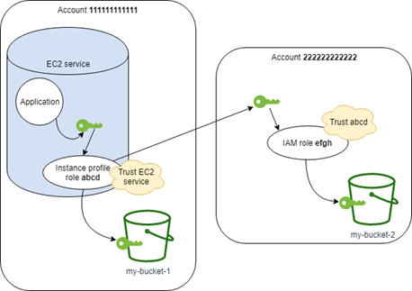

**Account 111111111111 *abcd* Role Permissions Policy—**

{

"Version": "2012-10-17",

"Statement": [

{

"Sid": "AllowAccountLevelS3Actions",

"Effect": "Allow",

"Action": [

"s3:ListAllMyBuckets",

"s3:HeadBucket"

],

"Resource": "*"

},

{

"Sid": "AllowListAndReadS3ActionOnMyBucket",

"Effect": "Allow",

"Action": [

"s3:Get*",

"s3:List*"

],

"Resource": [

"arn:aws:s3:::my-bucket-1/*",

"arn:aws:s3:::my-bucket-1"

]

},

{

"Sid": "AllowIPToAssumeCrossAccountRole",

"Effect": "Allow",

"Action": "sts:AssumeRole",

"Resource": "arn:aws:iam::222222222222:role/efgh"

}

]

}

The abcd role must trust the Amazon EC2 service to assume the role. To do this, the abcd role must have the following trust policy:

**Account 111111111111 *abcd* Role Trust Policy**

{

"Version": "2012-10-17",

"Statement": [

{

"Sid": "abcdTrustPolicy",

"Effect": "Allow",

"Action": "sts:AssumeRole",

"Principal": {"Service": "ec2.amazonaws.com"}

}

]

}

**Account 222222222222 *efgh* Role Permissions Policy**

{

"Version": "2012-10-17",

"Statement": [

{

"Sid": "AllowAccountLevelS3Actions",

"Effect": "Allow",

"Action": [

"s3:ListAllMyBuckets",

"s3:HeadBucket"

],

"Resource": "*"

},

{

"Sid": "AllowListAndReadS3ActionOnMyBucket",

"Effect": "Allow",

"Action": [

"s3:Get*",

"s3:List*"

],

"Resource": [

"arn:aws:s3:::my-bucket-2/*",

"arn:aws:s3:::my-bucket-2"

]

}

]

}

**Account 222222222222 *efgh* Role Trust Policy**

{

"Version": "2012-10-17",

"Statement": [

{

"Sid": "efghTrustPolicy",

"Effect": "Allow",

"Action": "sts:AssumeRole",

"Principal": {"AWS": "arn:aws:iam::111111111111:role/abcd"}

}

]

}

AWS IAM Policies-

Types of policies-

1. Identity based policy- Policies that are attached to an user/role. Cant be attached to root user.

2. Resource based policy- Policies attached to an AWS resource like S3,SNS etc. Root user can be mentioned as principal.

3. Permission boundaries- It set a boundary for no. of permissions that an identity based policy can have. It doesn’t apply for resource based policy. Not applicable for root user.

4. Organization SCP- It sets a boundary for no. of permissions that can be associated with an account user. Applies to both identity based and role based policy. Root user is affected.

5. ACL- It is similar to resource based policy with following difference- It is cross account permission policy that grant permission to the specified principal. It cant grant permission to entities within same account. Root user is affected of another account.

6. Session policies- The policies that limit permission for a created session.

Evaluating effective permission with permission boundary-

1. Identity provider with permission boundary-


                Evaluation of identity-based policies and permissions boundaries
            

1. Resource based policy- Permission boundary doesn’t limit permission attached to resources . So no explicit deny for resource based policy


                            Evaluation of a resource-based policy, permissions boundary, and
                                identity-based policy
                        

1. Organization SCP- Permission boundary applies to organization SCP since it controls over the roles/users of an account


                Evaluation of an SCP, permissions boundary, and identity-based
                    policy
            

1. Session policies-


                Evaluation of a session policy, permissions boundary, and identity-based
                    policy
            

-Permission boundary is attached to an user which defines the maximum range of permissions that an user can have. It doesn’t assign permission to user.

Controlling access using IAM tags-

1. Request tag-> aws:RequestTag/key-name🡪 requests for a tag
2. Resource Tag-> aws:ResourceTag/key-name🡪tag attached to a resource
3. Principal Tag->aws:PrincipalTag/key-name🡪tag of the principal
4. Use the **aws:TagKeys** condition key to control whether specific tag keys can be used on a resource, in a request, or by a principal.

Examples-

Specific access during a date range-

{

"Version": "2012-10-17",

"Statement": [

{

"Effect": "Allow",

"Action": "*service-prefix*:*action-name*",

"Resource": "*",

"Condition": {

"DateGreaterThan": {"aws:CurrentTime": "2020-04-01T00:00:00Z"},

"DateLessThan": {"aws:CurrentTime": "2020-06-30T23:59:59Z"}

}

}

]

}

Enable/Disable aws region-

{

"Version": "2012-10-17",

"Statement": [

{

"Sid": "EnableDisableHongKong",

"Effect": "Allow",

"Action": [

"account:EnableRegion",

"account:DisableRegion"

],

"Resource": "*",

"Condition": {

"StringEquals": {"account:TargetRegion": "*ap-east-1*"}

}

},

{

"Sid": "ViewConsole",

"Effect": "Allow",

"Action": [

"aws-portal:ViewAccount",

"account:ListRegions"

],

"Resource": "*"

}

]

}

IAM customer managed policy supports versioning. By default it has versioning enabled and upto 5 versions can be stored.

Versioning is not supported in inline policies.

Security best practices in IAM-

* Lock root account access
* Create individual IAM users
* Give least required privileges to the users
* Give customer managed policies rather than inline
* Use access levels to review permissions
* Enable MFA
* Use roles to delegate permissions
* Use policy boundaries

SAML integration-

We can setup identity provider when we want to establish trust relationship with an Idp which follows SAML(Security Assertion Markup Language) 2.0 standards.

To do this-

* We need to register identity provider in the IAM console
* Add provider->choose SAML
* For Metadata go to Idp and generate it and download. Attach this metadata to identity provider in IAM.
* Assign IAM role to your identity provider to let the users access AWS resources.

In this step we have our AWS account trusting the Ipd with the help of metadatas which contains issuer’s name, expiration info and keys to authenticate SAML users.

Now the next step is that our Idp should know about AWS as a service provider. To do this upload the AWS metadata(https://signin.aws.amazon.com/static/saml-metadata.xml) on the IPD provider.

Amazon Elastic Container Services(ECS)

Its is a highly scalable, fast container management service that makes it easy to run,stop and manage containers in a cluster.

Container is a task definition that we use to run an individual task.

We can run these tasks on a serverless infrastructure called AWS Farget or a cluster of Ec2 instances managed by user.

Basic Concepts-

1. Containers and images – container is an unit/entity which contains all the things that is required to run your application like code, required software etc.

Containers are created from read only template called images.

Images are build from DockerFile which is a plaintext file and includes all the info about what all is present in a container.

Images are stored in registry from where it is downloaded and used.

1. Task Definitions- It’s a text file which that describes one or more containers (upto 10) that form the application. It specifies various parameters (like port, data volumes) for the application.
2. Clusters- It’s a logical grouping of tasks and services.
3. Container Agent- it runs on each container instance within ECS cluster. It sends info about resource’s running tasks. It stops/starts tasks whenever it receives request from ECS.

Docker Engine-

It is technology that provides tools to build, deploy run and test your application on a Linux based container. It is an open source software. It is written in Go language.

Docker is Platform as a Service.

If container works on the host OS(say linux) then how are we able to get Ubuntu or RHEL image working in our container? --> Ubuntu/RHEL/Kali Linux are 95% written in linux. Container picks up the 95% code form host OS and rest 5% from the docker hub image and runs Ubuntu/RHEL OS on container. Since docker doesn’t take any resource from hardware but from OS so it is called OS level vitualization. Container has OS but the OS file is very small and negligible.

Advantages of using docker- less cost/light weight/less bootup time/less time to create image/can reuse image/no pre initialization of RAM/ CI efficiency increases

Disadvantages- Doesn’t provide cross-platform compatibility/ not good for applications that require rich GUI/no solution for backup and data recovery/suitable when development and testing OS are same.

Container has layered file system—it works on layer like 1st Ubuntu will install 2nd google chromo will and so on. The softwares are getting installed one after other rather than together

Docker Images are used to launch a container. After creating the docker image we push it to registry(ECR/ Docker Hub)

Working of Docker-

1. Create Docker file- dependencies and required software
2. Run the docker file in docker engine/daemon🡪 this creates an image
3. This image will start container

Docker Ecosystem-

1. Docker Client- we can write code/ create file etc through docker client. Docker user can interact with docker daemon through docker client (CLI)
2. Docker deamon/server/engine- responsible for making image/ create container
3. Docker hub- Storage for images
4. Docker image- template for creating container
5. Docker compose- helps to run many docker conatiners

Docker installation- yum install docker –y

To see images – docker images

Find out image in dockerhub- docker search <image_name>

To download image from dockerhub to local machine- docker pull <image_name>

To give name to container- docker run <interactive mode> <open terminal> --name <container_name> <image_name> /bin/bash . Eg-> docker run –it –name mycontainer Ubuntu /bin/bash

Check docker status- service docker status

Start container—docker start <container_name>

To go inside container- docker attach <container_name>

To see all containers- docker ps –a

Stop container- docker stop <container_name>

To delete container- docker rm <container_name>

View info – docker info

To check running OS inside container- cat /etc/os-release

To see difference between base image and changes on it – docker diff <container_name>

Create image from a container- docker commit <container_name> <image_name>

To create image out of docker file- docker build –t <tagname> <dirNameWhereDockerfileIsPresent>

Creating Dockerfile-

1. FROM - base image name.
2. RUN – to execute commands
3. MAINTAINER- Author/description of dockerfile
4. COPY- copy files from local machine(docker VM). Cant download anything from internet
5. ADD- similar to COPY but provides additional feature of downloading from internet as well extracts the zip file
6. EXPOSE- exposes port in docker
7. WORKDIR- sets working directory for container
8. CMD- execute command during container creation
9. ENTRYPOINT – similar to CMD but has higher priority over CMD
10. ENV- environment variable
11. ARG
12. VOLUME – creates volume

Docker Volume🡪

Volume is a directory in container. We have to declare it as volume and then share it. Volume is a shared space in which multiple containers can share file. Volume remains even if container is deleted. We can declare a directory as volume only at the time of container creation.

Volume wont be incuded when we create image of the container, the file will the present but it wont behave as shared volume.

It can be share container to container and host to container.

Advantages- on deleteing container vol doesn’t get deleted.

-we can share vol amongst diff containers

-attach volume to various containers

To share volume across diff containers- docker run –it --name container2 --privileged=true --volumes-from container1 ubuntu /bin/bash

To share volume to host- docker run –it --name hostCont –v /home/ec2-user:/container_directory_to_map --privileged=true Ubuntu /bin/bash

Difference between exec and attach- exec starts a new process but attach doesnt

Docker Port expose-

docker run –td --name container_name –p hostport:containerport image.( -td is for create the container but do not login me) Eg- docker run –td --name con1 –p 80:80 ubuntu

By using expose, the container can connect to another container but not to an external user. But by using –p we can interact with outside user

ECS Cluster-

It’s a logical grouping of tasks/services. Cluster concepts-

-it is region specific

-clusters can contain many container instances but each container instance can be registered with only one cluster at a time.

Scaling in and out of instances can be managed by “Capacity Providers” which in turn is associated with an autoscaling group. We can define a “target capacity” to control the capacity of an instance and scale in or out according to that. When using capacity provider, it creates a scaling in and scaling out plan which is monitored by a “target scaling policy” created on your behalf.

Task definition defines parameter that are required to run a task on container

ECS container agent allows container instances to connect to the cluster.

Secrets Manager

AWS service where we can store the secret and rotate it as well. Secret is stored in an encoded format.

SM encrypts the protected text with a KMS customer managed key. This CMK can be default one or created by customer. KMS ensures secure encryption of your secret when at rest.

Whenever SM encrypts a new version of protected secret data, SM requests KMS to generate a new data key from specified CMK. This data key is used for envelope encryption and is stored with the protected data in encrypted format. Whenever secret needs decryption, KMS decrypts with the help of data key and then immediately dispose the data key.

SM only accepts requests from host using TLS and PFS (Perfect Forward secrecy).

Staging labels helps us to keep track of different versions of secret. Each version can have multiple staging label but the reverse is not true.

Secret Rotation-

We can rotate the secret manually after a time interval. Secret rotation also changes the passwords in the databases which are compatible with the SM service. If not compatible, then we have to build a lambda function which will change the passwords in the required places whenever rotation happens.

By default “AWSCURRENT” labeled version is picked when SM is called until we mention any specific label/version. A label is unique amongst all the version. We cant create 2 labels with same name in 2 different versions.

The following stages occur whenever rotation happens—

-The rotation function creates a new set of credentials to access the db. It stores the new cred with a label AWSPENDING

- Rotation function tests the AWSPENDING version to ensure new version is working fine.

-Once tested and everything goes fine, the AWSPENDING is changed to AWSCURRENT ant the previous password label is changed to AWSPREVIOUS

Staging label- A label given to different versions of secret. A version can have upto 20 labels but the reverse is not true. Label is unique amongst all the version of a secret. A version must always have a staging label attached to it.

Version- Multiple versions of secret can exist which is differentiated by the label attached to it.

When an IAM principal in one account tries to access secret form another account then that secret must be encrypted with a CMK and permission to access both secret and CMK must be given. Default KMS cant work coz it can allow access to principal of its own account. Alternatively we can create a role to access KMS and secret in the account where secret is present and attach it to the user of another account.

Secret Rotation-

When we enable secret rotation by using the “Credentials for RDS”, “Creds for RedShift cluster” and “Creds for DocumentDB” , SM provides you with a lambda which rotates the in both places.

But if we are using any another type of secret then we have to write lambda on our own to rotate the secret in the 3rd party provider.

By default SM endpoints runs on public internet.

Simple System Manager (SSM)

Service which we use to view and control our infrastructure on AWS.

For SSM to operate in our server, we need to have ssm agent installed in our system as well as proper IAM permissions attached to the instances to let the SSM run on it.

SSM agent is a software which lets SSM operations to be run on our instances.

Different types of management under SSM-

1. Operations Management- It helps us to manage AWS resources.
2. Application Management- It helps us to manage the applications running on AWS.
3. Change Management- It helps in changing the AWS resources
4. Node Management- It helps to manage ec2, on premise servers and virtual machines in hybrid environment.
5. Shared resources- It is shared amongst various ec2.

SSM agent has root access on our instance. So we should have proper IAM restrictions to avoid any malicious code to be run in our ec2.

How to reference AWS SM secret through Parameter store parameters-

By using PS we can call out the secrets stored in SM. The following boundaries apply-

* We can retrieve SM secret only by using “getParameter” and “getParameters” and not by any other call like “getParameterByPath”.
* When we retrieve secret from PS then the parameter name should be like-

/aws/reference/secretsmanager/secret_ID

* If an user doesn’t have access to a secret then he cant retrieve that secret even by using PS.
* PS reference to SM cant use PS versioning feature.

Operational Management-

1.Explorer- It is customizable dashboard that reports information about AWS resources. It helps us to understand the state and operational risks of AWS resources. Eg- ec2 instance CPU utilization, detached EBS volumes, etc. It is a report hub where DevOps managers view summaries of operational data.

2.Opscenter- It provides a central location where engineers can view, investigate and resolve the operational works related to AWS resources. It provides data for each issue and thus reduces the total time of resolution. It is integrated with Amazon Event Bridge and CloudWatch. It provides data collected from different AWS services on a single dashboard.

3.Cloud Watch- It is a customizable dashboard that can monitor resources under a single view even of another region

4. Personal Health dashboard- it monitors the health check of resources in our aws account.

Application Management-

1.Application Manager- It helps to investigate the issue in terms of application. It collects data from various AWS services and display under a single console.

2.AppConfig- used to create, manage and quickly deploy application configurations. We can use app config with applications hosted on ec2, lambda, containers etc.

3. Parameter Store- It is a secure and scalable secret management service with no servers to maintain it. It supports 3 types of parameters- String, String List, secureString.

String- It contains a single string

StringList- Comma separated list of values

SecureString- Any sensitive data that needs to be stored and referenced in a secure manner. The data is encrypted/decrypted using a KMS key.

2 tiers of PM-

1.Standard parameter- size of parameter is 4kb. No. of parameter limit-10000

2.Advanced parameter- size of parameter is 8kb. No. of parameter limit-100000

Advanced parameter cant be converted into standard while the vise versa is possible.

3.Intelligent tiering- It automatically updates PS from Standard to Advanced tier on the basis of size of parameter/ no of parameters stored.

We can increase the max no of transition in PS by setting up throughput limit.

About storing parameters-

* Parameters are case sensitive
* Parameters cant include spaces
* Valid characters- a-z A-Z 0-9 _ . –
* Length of arn can be upto 1011 characters
* Hierarchy depth can be upto 15

Change Management-

Change Manager- It is used for managing the changes to both AWS resources and on premise resources

Automation- It helps in maintenance and deployment tasks of AWS resources.

Change calendar- It helps us to set up date and time ranges actions has to or not to be performed.

Maintenance Window- It helps to define a schedule for when to perform maintenance activities such as patching.

Node Management-

Fleet Manager- we can view health and performance of entire server fleet/group on a single console. We can also perform common tasks on the entire fleet by using this service.

Compliance- we can use this service to scan the fleet of managed instances for patch compliance and configuration in consistencies.

Inventory- It provides visibility into ec2 instances. Using this service we can collect metadata from the instance

Managed instances- List of instance in which AWS SSM is configured

Session manager- It helps to securely login to an instance without need of opening the port or maintaining a bastion host and ssh key. SM creates a TLS1.2 encrypted channel between the user and the machine by looking into the IAM permission of the user

Run Command- It lets us to run any command on the managed instances securely.

State manager- It is a service which automates the process of keeping ec2 in state that we define. It can be used to run commands on the ec2 instance for lifetime. State Manager “association” is the configuration that is to be carried out in the instance. “Schedule” is defined with associate which says when the association has to be applied

Patch Manager- It updates/patches the managed instances with security related and other updates.

Distributor-

Shared resource-

SSM document- It is set of commands written in form of document which can be run in any managed instance.

AWS LAMBDA-

It helps us to run any code without provisioning or managing server. It is also called serverless computing. We have to pay only for the compute time. No charge for the code which is not running. We can also configure lambda to run in response of an event such as changes of data in s3 or dynamo db.

Concepts-

Function- It is a resource that we invoke to run the code.

Execution environment- It provides a secure and isolated runtime env for Lambda function.

Deployment package- We deploy the code using this package. Lambda supports-

* A .zip file archieve
* A container image that is compatible with Open container initiative.

Layer- A .zip file which contains all the libraries and dependencies.

Runtime- The language in which the code is written. It provides language specific env that runs in execution env.

Event- it’s a json formatted document that contains data required for the lambda function to run

Interview questions---

Can we launch instances of multiple type in an autoscaling? – Yes we can. If we do not define any instance type in the launch template, then we can define demand/on spot instances in the autoscaling configurations. We can define the capacity that we can send to demand and on-spot. Also we can choose different instance type and define weightage against it.

Max no of policies that can be attached to IAM user/role- 10 by default and can be increased upto 20.

No 0f groups- 300(default) 500(max)

No of roles in an account- 1000(default) 5000(max)

Access key assigned to IAM user- 2

Access key assigned to root user- 2

Can we associate multiple target group under one auto scaling group?? – Yes

What is maximum size of ebs volume??—16 TiB

How do we access the instance if we lost key pair of it?--> Stop the instance and launch a temporary instance. Detach the root volume from original instance and attach to temporary instance. Login to temp instance and then change the key in authorized_keys for the original instance’s root volume. Now detach this volume and attach to the original instance.

AWS services which are not region specific- IAM/ Cloudfront/ Route53/ AWS WAF

Different types 0f AMI-

1. Fully baked AMI- It’s a ready to use AMI in which the OS, logging and required softwares are pre installed.
2. Just OS AMI- Only the OS agent is baked. On top of it we have to deploy the required software/runtimes, logging, monitoring and security. It is very flexible.
3. Hybrid AMI- The OS along with security, logging and monitoring is baked. Runtimes have to installed at time of deployment.

How can we easily delete the snapshots after a certain time period- Using Ops Automator. It allows to create, copy and delete EBS.

Difference between EBS and EFS?

What is burstable instance?

Difference between CF and AWS Beanstalk-

CF- It creates and manages the entire infrastructure including ec2,ecs,etc.

Beanstalk- It provides and manages an env that can be used to deploy and run application

EFS doesn’t support snapshot. The data can be replicated from one EFS to another EFS.

2 types of routing provided by R53-

1. Latency based routing- Its goal is to minimize latency.
2. Geo based routing- Routing is done on the basis off the location from where you are hitting the request.

What is git and why is it preferred over other providers?

Git is a version control system used to maintain different versions of the code and the code can be reverted to any of the previous version anytime. It enables multiple developers to make changes to the code at the same time. It is distributed control system

There are 2 types of version control- centralized and distribution control system.

In centralized sytem, we don’t have local repository rather we have a local working copy. All the commits and push is done in the central repo.

IN distributes control system we have 3 layers- local copy, local repo, remote repo

We have many new files in local repo and we don’t want to add few of them to repo while doing git add. How can we achieve this?—create a .gitignore file and add the names of all th files that isn’t to be commited/pushed. Now run the git add cmd

Diff between git pull and git fetch-

Git pull- Fetches all the changes and merge it with your local branch. Git fetch+ git merge

Git fetch- it just fetches the remote repo.

How to clone a particular branch?- using git checkout or git clone – b <branchname> --single-branch <clone_link>

Difference between .war and .ear

Does tomcat support .ear?

Which application supports .ear?

What is catelina in tomcat?

What is jvm and jre?

JDK- It is a kit which provides the env to develop and execute the java program. It includes 2 things- 1.development tool 2.JRE

JRE- it’s a package that provides environment to only run the java program in your machine

JVM- It is responsible for executing the program line by line

Log file name for tomcat?—dotcms_access.YYYY-MM-DD.log

Slaves in Jenkins- For windows—use JNLP/ for linux configure keys to establish connection

What is maven archtype?— sample template which can be created for you by maven

How to get separated value of CSV file in inux?-- awk -F, '{print $1,$2,$3}' aa.csv

What is shebang in linux? Absolute path to bash interpreter

How to replace all occurrence of a word in linux? sed ‘s/textToBeReplaced/NewText/g’ file_name

Read terraform

Structure of Jenkins home directory-- /var/lib/jenkins—to change it make change in JENKINS_HOME in file /etc/sysconfig/Jenkins and for windows—change web.xml in Jenkins.war file

What is work flow lib in Jenkins?- it provides ability to share common libraries across many workflow jobs

Can we implement folder level access from Jenkins ?

How to change port no of Jenkins?—go to /etc/default/Jenkins, add --httpPort=xxxx to JENKINS_ARGS and restart jenkins

What is webhooks and how to do it?

Upstream/downstream in Jenkins?

Upstream job triggers another job as its execution process

Downstream job is the one which gets executed by another job

Different components/features used in the environment-

Netscaler WAF rules protects from the below mentioned attacks-

1. Injection-

* It is configured to prevent SQL injection. We can also configure custom rules to avoid this kind of injection.
* It auto updates the signature so that signatures are upto date.
* Form Field consistency feature help to learn the pattern and later we can configure it to block/unblock based on pattern.
* Buffer overflow checks are present which determines the length of the request.

1. Broken authentication and session management-

Netscaler keeps track of cookies in use and doesn’t accept the request if the cookies are tampered.

1. Cross site scripting(XSS)-

XSS is tampering with the web page and including malicious code into it. NS field format can be used to prevent this attack

1. Insecure Direct Object Refernces-

NS is configured with start URL checks that allows user access to a predefined whitelist of URLs.

1. Cross site request forgery-

In this attack the attacker makes the user to do changes to its account unintentionally like changing the email id or password and thus the attacker gains full control over users account.

NS comes with CSRF whitelisting feature to avoid this attack.

Protection against DDOS attack-

Protection against Layer 3-4 SYN DDos attack- Ns maintains a SYN cookie rather than a half-open connection. Full connection is established only when ACK packet is received. This prevents DDOS attack in SYN.

Mulesoft-

It is used as an API gateway where all the APIs are exposed. It provides secure access to APIs. In our env the APIs are not build on mule rather the security policies are applied on mule for all the APIs. So Mule proxies are deployed so that mule can interact with the APIs hosted in non mule platform.

Working of mule-

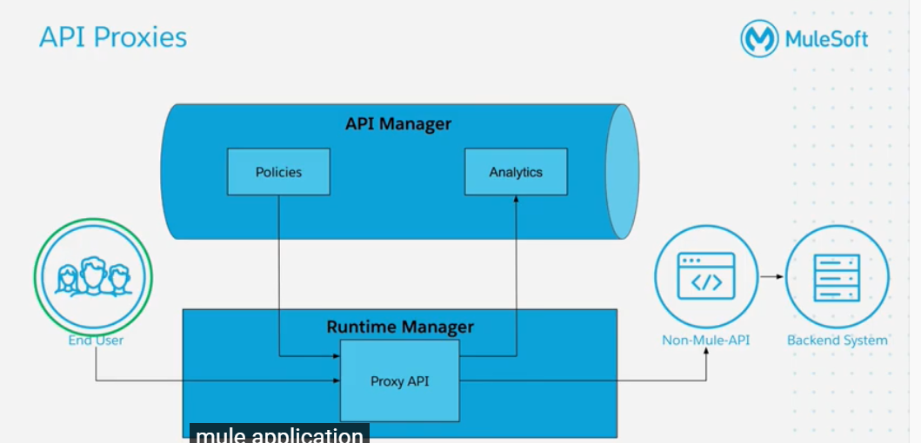

End user requests for an API. The request goes to runtime manager which takes the API ID to pull the Policies from API Manger. If there is no violation of the policy then the flow will to to Proxy API. Mule runtime analyses the request and sends back the analytics to Analytics in API Manager. The request goes to non mule API proxy which forwards it to the backend system.

Jenkins—

Jenkins is an open source automation tool written in java with plugins build for continuous integration. It makes it easy for the developers to maintain version and do unit testing.

Work flow of Jenkins- It checks for any change in source code at regular interval. If yes, then it prepares for build and notifies the user. If build fails it notifies the user.

Benefits of using Jenkins-

* Cache build failure
* Automatic build report notification
* Achieves CI
* Automation of maven project
* Easy bug tracking in early stage

How to install Jenkins-

1. Install Java 8
2. Download Jenkins package(linux)/In windows- download the war file.
3. Sudo yum update and sudo yum install Jenkins (linux) and for windows run- java –jar Jenkins.war
4. Open Jenkins on localhost:8080 and Install plugins

To start/stop Jenkins manually— jenkins.exe start

How can you clone a repo via Jenkins- Enter email and user name. Now execute the cmd- git config

How to setup Jenkins job- From Jenkins dashboard select New Job. Select build free project. Now mentions SCM(where Source code resides).configure optional triggers, build script that builds the project. Now configure the optional options such as archieving the artifact or build results.

Appspec file have hooks in it which we can define different deployment lifecycle events, such as-what has to be done before installation after installation etc. It can outline the files that are required, parameter that needs to be set and commands that needs to be run by codeDeploy agent in your container. Eg-

version: 0.0

os: linux

files:

- source: /

destination: /var/www/html/WordPress

hooks:

BeforeInstall:

- location: scripts/install_dependencies.sh

timeout: 300

runas: root

AfterInstall:

- location: scripts/change_permissions.sh

timeout: 300

runas: root

ApplicationStart:

- location: scripts/start_server.sh

- location: scripts/create_test_db.sh

timeout: 300

runas: root

ApplicationStop:

- location: scripts/stop_server.sh

timeout: 300

runas: root

Buildspec file- It is collection of build commands and related setting. It tells what has to be done in pre-build,build and post build phases. Eg-

version: 0.2

run-as: Linux-user-name

env:

shell: shell-tag

variables:

key: "value"

key: "value"

parameter-store:

key: "value"

key: "value"

exported-variables:

- variable

- variable

secrets-manager:

key: secret-id:json-key:version-stage:version-id

git-credential-helper: no | yes

proxy:

upload-artifacts: no | yes

logs: no | yes

batch:

fast-fail: false | true

# build-list:

# build-matrix:

# build-graph:

phases:

install:

run-as: Linux-user-name

on-failure: ABORT | CONTINUE

runtime-versions:

runtime: version

runtime: version

commands:

- command

- command

finally:

- command

- command

pre_build:

run-as: Linux-user-name

on-failure: ABORT | CONTINUE

commands:

- command

- command

finally:

- command

- command

build:

run-as: Linux-user-name

on-failure: ABORT | CONTINUE

commands:

- command

- command

finally:

- command

- command

post_build:

run-as: Linux-user-name

on-failure: ABORT | CONTINUE

commands:

- command

- command

finally:

- command

- command

reports:

report-group-name-or-arn:

files:

- location

- location

base-directory: location

discard-paths: no | yes

file-format: report-format

artifacts:

files:

- location

- location

name: artifact-name

discard-paths: no | yes

base-directory: location

exclude-paths: excluded paths

enable-symlinks: no | yes

s3-prefix: prefix

secondary-artifacts:

artifactIdentifier:

files:

- location

- location

name: secondary-artifact-name

discard-paths: no | yes

base-directory: location

artifactIdentifier:

files:

- location

- location

discard-paths: no | yes

base-directory: location

cache:

paths:

- path

- path

CI Pipeline- Continuous Integration— Code/Build/Test

The code is pushed by API team on bit bucket. In the CI pipeline, the code is retrieved from the bit bucket, unzipped, few values are changed according to the env., the code is then pushed to S3 bucket. At end of CI we have an artifact that is input for CD

CD pipeline- Provision/Deploy/accept test

It compiles the source code, runs tests and produce software package that is ready to deploy

It creates an image and then pushes it to the ECR. It creates a task definition with all the necessary information to run the task. After creating the task definition it creates service in cluster.

Jenkins Setup – Install Jenkins on the server. It will automatically start at port 8080. Login to the instance using http://<publicIP>:8080. It will ask for a password that is present in the mentioned file. Put that password and then it will ask for setting up permanent user and password. Install the recommended plugins.

Master-Slave architecture – Master is just the controller and actual runtime is the slave. All the required softwares for building the project needs to be installed in the slave. We need to configure a new node and do the required settings like provide the IP of the slave, key to login into it.

First go to manage Jenkins->configure global security->agents-> Set TCP port to “Random”-> save

For key- Generate a key in the master(ssh-keygen). Copy the public key to the slave instance’s authorized_key. Try doing ssh from master to the slave. The host name and a cipher will be populated in the known_hosts file of the master and the master will be able to connect to slave. In the UI the slave will show connected to master.

Create new node on Jenkins console. Give root directory, labels, usage. In launch method select “launch agent via SSH”. Give agent’s hostname and key to connect to it. Select known host file verification strategy and save.

For Windows slave- in launch method select “launch agent by connecting It to master” and save. Now click on the agent. And there are 3 options to start activate agent. Place agent.jar in the slave and run the command given on console

Development of pipeline and groovy- We can trigger another job on finishing of the 1st job. This is called pipeline. We can also define this pipeline as a code written in groovy rather than configuring it from console. 2 types of pipeline-

1. Scripted pipeline- Groovy script is written in Jenkins console. Syntax-

node {

stage(‘Build’){

//

}

stage(‘Deploy’){

//

}

}

1. Declarative pipeline- Jenkins file is created and stores in an SCM, pulled and then run. Syntax-

pipeline {

agent any

stages {

stage ('clean workspace') {

steps {

deleteDir()

}

}

stage('Non-Parallel Stage') {

agent {

label "master"

}

steps {

echo 'This stage will be executed first'

}

}

}

How do we build a project with multiple git repo🡪 using a plugin called Multiple SCM, we can configure the job to pull code from several git repo

Difference between monolithic application and microservices—

In an application say Uber, all the module like location notification payments mail, etc were present in the same server and interacted with each other. Single deployment.

In microservices, we have all these module are deployed separately and they interact with each other using json. Now if all the modules were deployed in different instances then we might require many ec2 which wont be fully utilized all the time. So we introduced dockerization where multiple microservices can be run in a single ec2 independent of each other.

Now how do I manage these containers? How do we orchestrate the containers?—Kubernetes/ ECS. Kubernetes gives a lot of flexibility with what we can do with our containers.

Kubernetes is a container orchestration tool used for applications distributed over multiple containers. Its job is to monitor, scale, restart containers automatically

What is blue-green deployment?—it is a design pattern which reduces the downtime and also reduce the risk by running 2 identical application in the production env. Blue is the current prod env and green is the new version to be deployed. Only a specific set of users are redirected to use the green env. Once proved to be working fine slowly all users are shifted to green env and green env is removed.

How does maven work?—we have a file pom.xml where all the dependencies are defined, which are 1st searched in local repo else central repo. Then in our Jenkins pipeline we define what has to be done like mvn compile, mvn package etc.

Settings.xml in maven—if defines local repo location, alternative remote repo location and authentication required for private repos.

Pipeline- it adds powerful automation tools into Jenkins which can help from CI to CD by modeling a series of related tasks. Advantages-

-pipeline can be implemented as code

-pipelines are durable and can survive both planned and unplanned restart of Jenkins master

Pipeline terms-

Step- A set of commands that has to be run.

Node- A machine in the Jenkins env which is capable of executing a pipeline

Stage- Logical division of various steps in a pipeline

Global Variable reference- It contains various variables provided by plugins in Jenkins

To refer to these variable- env.PATH

Params- user defined parameters for a job. Eg- params.my_parameter_name

Current build- used to get info about currently running pipeline. Eg- currentBuild.result

Multi-branch pipeline- Multibranch pipeline project enables us ti implement diff Jenkins file for diff branches of same project. Create a multibranch pipeline and give the git details. Now Jenkins will automatically scan the repo and create required settings for each branch in the repo

Different types of projects in Jenkins-

1. Freestyle project- It is a simple and very basic project.
2. Maven Project- Jenkins takes the config from pom.xml automatically and thus no extra configs are required to communicate with Jenkins
3. Pipeline- It is used for complex projects which contains multiple build stages and can have different agents as well
4. Multi-configuration project- Suitable for projects that need large no of diff configurations such as testing on multiple environements.
5. Multibranch pipeline- Creates a set of pipeline projects depending on the Jenkins file on multiple branches in 1 SCM repo

MANAGE JENKINS-

1. Configure system-

Home directory- where Jenkins stores all its data. Can be changed by editing the file /etc/sysconfig/Jenkins. For windows- edit web.xml

Maven project configurations- like m2 repo, labels etc

Jenkins URL- Jenkins URL/domain

1. Global tool configuration-

Maven config- like default setting provider and JDBC URL and credentials if using windows server

1. Manage plugins
2. Manage nodes
3. Configure global security- Authentication, authorization, port allowed for agent/slave connection etc settings
4. Manage credentials
5. Configure credential provider
6. Manage users

How do we notify to master if a slave is down—turn on the “Notify when node online status changes” and mention the email id on which the email has to be sent

Difference between docker and Virtual machine?

Virtual machines have host OS and guest OS on top of it. Docker just has host OS.

Docker containers are suitable for applications that run on same OS whereas VM is required for applications that run on different OS.

Root access shouldn’t be given to docker since 1 host OS is shared amongst many applications.

Scaling up/down, restart OS is faster in docker

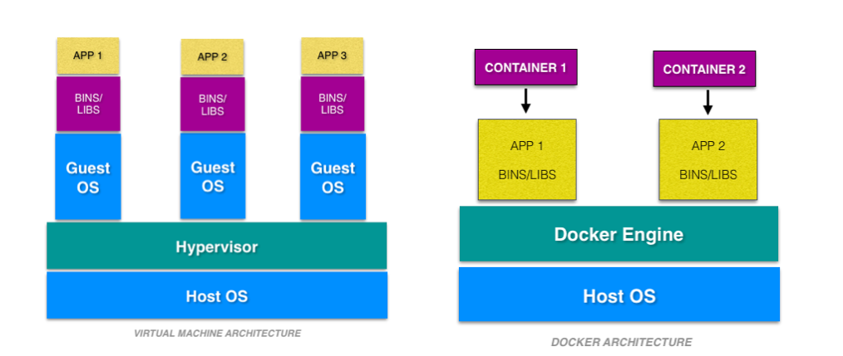

Devops- It aims at better communication between development team and testing team. It also aims to introduce automation at every step. Before devops, the code was created by development team and then sent to tester for testing and then the testing teams sends the artifacts for deployment. But with devops, the developer can put its code into a SCM and the tester can put in another branch of SCM. The code can be pulled from SCM, build, test code being applied in a automated way, which created an artifact that can also be deployed automatically.

Docker ps –a – list all container

Docker start container_id

To create new container form a image- docker run <option> image <cmd> <argument>

Stop container- docker stop container_id

Kill – docker kill container_id

Remove all unused images- docker system prune or docker image prune

GIT Fundamentals—

Github/Bitbucket/Gitlab provides service at remote(central) repository level and git provides service at local repo/local copy level.

Local repo structure-

Workscape 🡪 Staging area 🡪local repo

Download and install git-

Yum install git –y

Git config --global user.name “amisha”

Git config --global user.email “[abc@gmail.com](mailto:abc@gmail.com)”

All commands for branching-

See current/available branch- git branch

Create new branch- git branch <branch_name>

Go to another branch- git checkout <branch_name>

Delete a branch- git branch –d <branch_name>

** If we create a new file in branch b1 then it will be visible from master and all other branches as well because it is present in workspace. But after git add and git commit that file becomes visible to b1 only and no other branch

Git merge conflicts—it occurs when there is conflict between 2 branches between the same file and place. To see the conflict—edit that file or git status. The conflict will be represented as <<HEAD……========……….>> Edit this file to remove conflict.

Git Stash—when we are working on something and then a new work comes in between and we don’t want to commit or lose our previous work then we can use git stash which behaves like a temporary storage and clears our workspace.

To stash an item- git stash

To see stash file list- git stash list

Stashing is given no {0} being the latest stash and the {1} {2} and so on

To apply stashed item- git stash apply stash@{0}

To clear stash- git stash clear

Git Reset <file_name>- used to undo local changes. Resets all the things in the staging area. To remove from staging area and workspace as well—git reset –hard

Git revert- this helps to undo existing commit. We don’t delete the unwanted commit rather it creates a new commit with files present in the previous state. Syntax- git revert <commit_id>

Remove untracked files – git clean –n or git clean -F

2 types of version control-

1. Central version control-

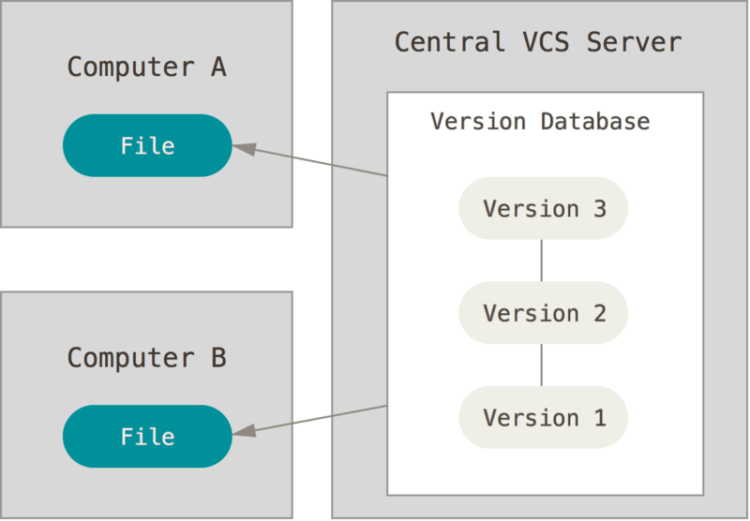

Only 1 central server is responsible for all the changes. If central server goes down no one can contribute to the project

1. Distributed version control-

The do not just copy the latest snapshot of files but they copy the repo including the history. Thus if the central server dies, the client can make changes in its local repo and then push it whenever server comes up.

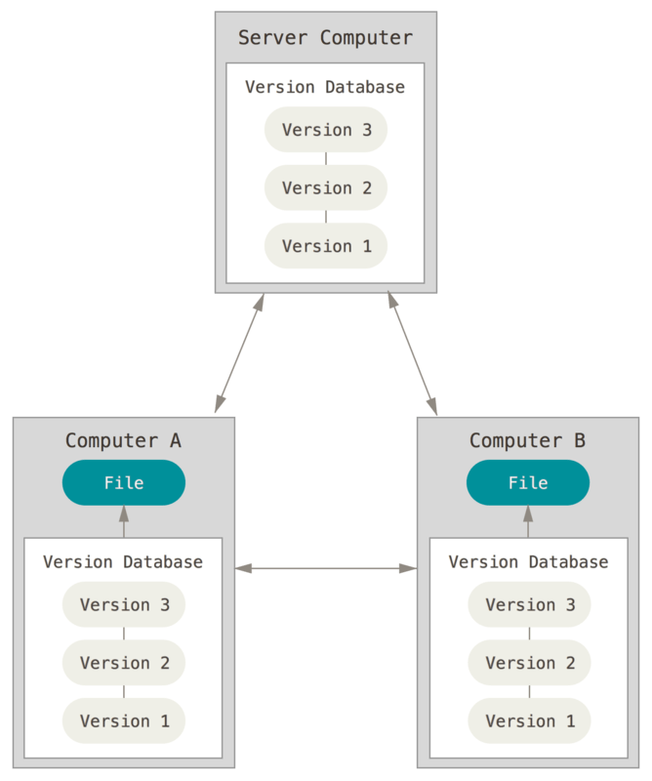

3 stages in Git-

1. Modified- changed the file but not committed to db
2. Staged- means you have marked modified file in its current version to go into your next commit snapshot.
3. Commit- data is safely stored in local repo

Default branch name is “master”. We can also set diff default branch name. eg- set default branch as main-

Git config --global init.defaultBranch main

Getting a Git repo-

1. You can take a local directory that is currently not under version control, and turn it into a Git repository

Go to the folder which you want to version control.

Type- git init

Git add *.c

Git add LICENSE

Git commit –m ‘Initial commit’

1. You can **clone** an existing Git repository from elsewhere.

Git clone <repo url>

How to add a new file into repo-

Create the file in local and then

Git add <filename>

How to stage a modified file-\

Use git add <filename>- its multipurpose cmd.

Git commit –m ‘message’

Gitignore- the files which we don’t want to be staged/committed anytime, we put name of those file in .gitignore file

Viewing staged and unstaged files- git status

To see what is changed but not staged- git diff

To see what is staged and will got to next commit- git diff --staged

Moving files- git mv file_from file_to

View commit history- git log

We can customize this logging by using several filter out mech

To undo commit- git commit --amend

Upstaging the staged file- git reset HEAD <filename>/ git restore --staged <file_name>

Unmodifying the modified file- git checkout -- <filename>/ git restore <filename>

Adding remote repo- git remote add <shortname> <url>

Git fetch- only downloads the data to local repo, it doesn’t merge it to your local repo

How git commits work- say we had added 3 new files and made a git commit. This is how it happens-

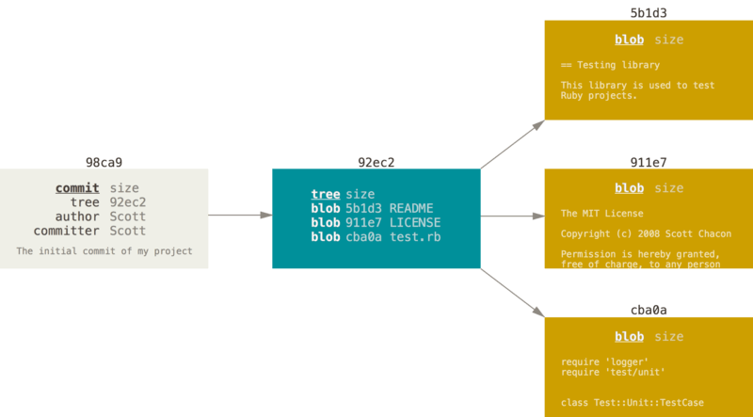

Snapshotting in git- The new tree/commit always points to its parent snapshot as shown-

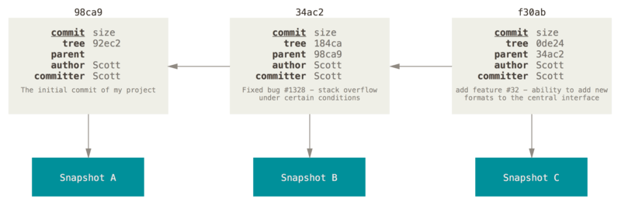

Creating a new branch- git branch testing

This creates a new pointer to the same commit you currently are in

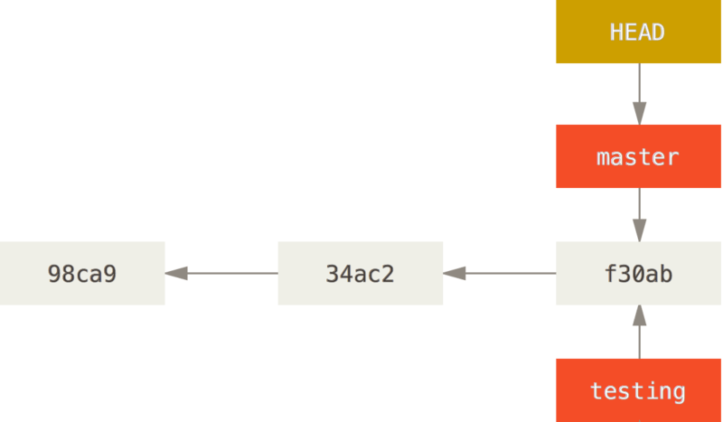

Now- git checkout testing

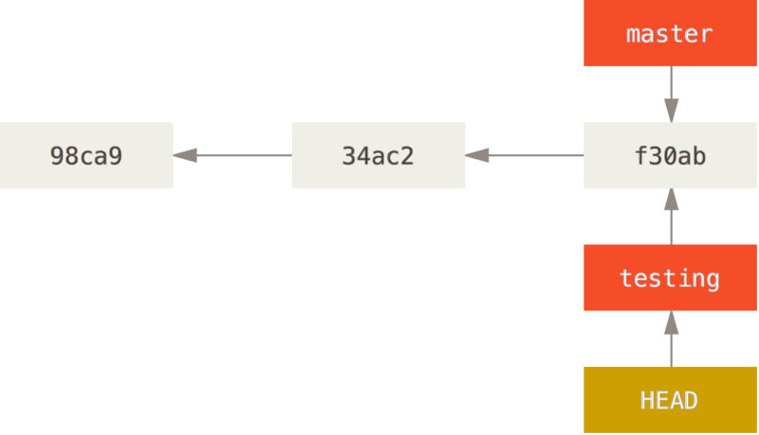

Now we make a new file and commit it- vim test.rb

Git commit –a –m “made a change”

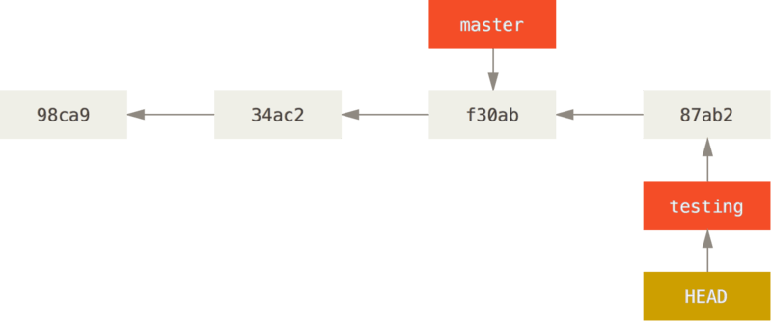

Now lets get back to master branch- git checkout master

And add file in master- vim test.rb

Git commit –a –m “made changes in master”

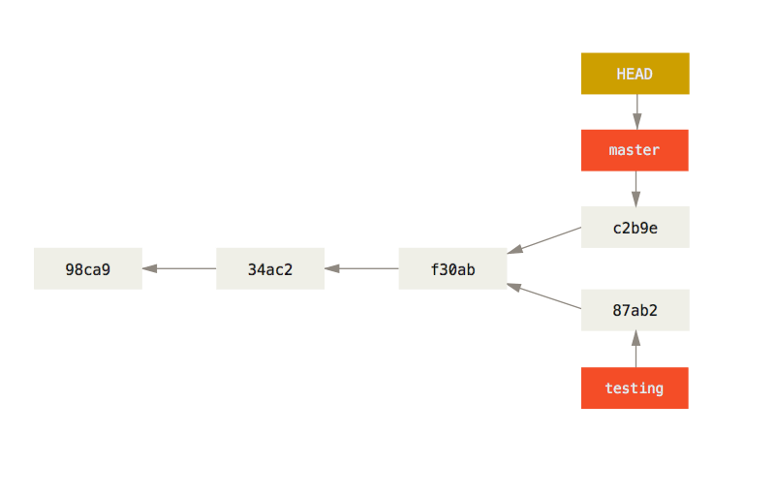

Merging the test branch to master-

Git checkout master

Git merge testing

Git branch –d testing ##delete the branch testing

Merge conflict- if we have changed same part of same file in 2 diff branches and want to merge it, git will create a merge conflict. To solve this issue first check which file has the conflict by “git status”

Changing branch name- git branch --move master main

Rebasing- It creates a copy of the new committed files of other branch into the master branch.

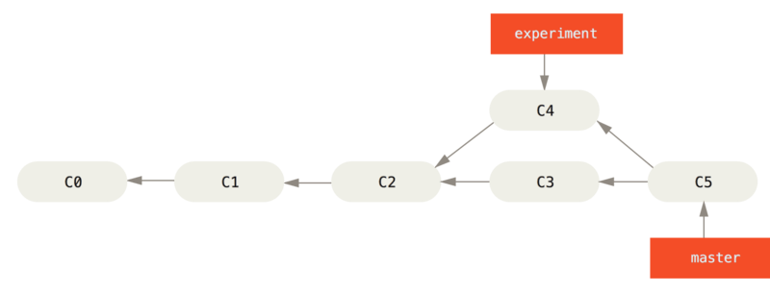

Git checkout experiment

Git rebase master

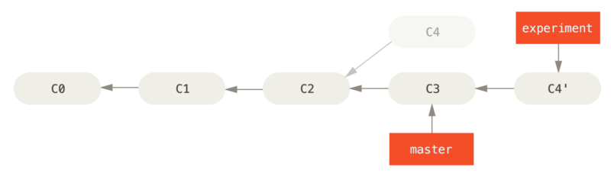

Git checkout master

Git merge experiment

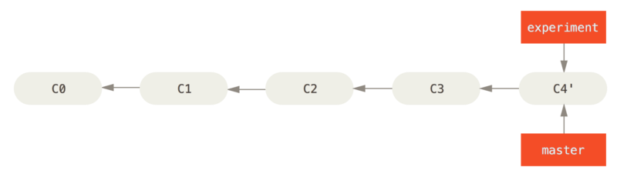

Git Flow model-

1. A master branch is creater
2. Devlop branch is creates from master branch
3. Release branch and feature branch are created from develop branch
4. When feature is complete its is merged to develop
5. When release branch is complete it is merged to both master and develop
6. If an issue is found in master, hotfix branch is pulled, after fixing the issue it is again merged to master and develop.

LINUX

Linux is kernel + GNU 🡪 Linux OS

OS originated from linux -> RHEL/Debian/Ubuntu/CentOS/Amazon linux

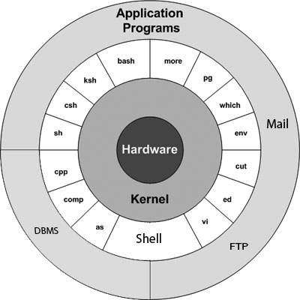

Init 0- cleans up and then power offs the system

Init 6- Restarting the system

Cat cmd- cat > file (creates new file/replaces file content) cat >> file1 (appends on file 1)

Touch cmd- creates empty file as well as updates the time stamp

Copy cmd- cp <source> <destination> (overwriting is done)

Cut and paste- mv <source> <destination>

Remove dir-> rmdir—for removing empty dir

Rmdir –p dir1/dir2🡪remove child and parent dir

Rm –rf 🡪 deletes both non empty file and dir

Rm –rp 🡪 removes non empty dir including parent and subdir both

hostname 🡪 gives details of machine

yum- yellowdog update modifier—used to update/install software

chkconfig <serviceName> on 🡪 to automatically start the service whenever ec2 is started

yum list installed – list all installed softwares

ifconfig/ cat /etc/os-release 🡪 gives ip of machine and more details

ln <filename> <backupfile name>🡪 hardlink🡪 used to make backup

ln –s <filename> <softlink name>🡪softlink

tar –xvf sample.tar 🡪extract the tar file

tar –cvf <tarname> <dirname> 🡪 create tar of given directory

Mkdir- make directory—mkdir test

If the parents directory doesn’t exists then use – mkdir –p /tmp/t1/test

Rmdir dirname- remove a directory

Chmod- change permission of file

Chown- change the owner of the file

Chgrp- change the grp pf the user that owns the file

/etc/profile—it contains shell initialization information required by all users on a system

PATH—location where shell should look for commands

grep <pattern> <file> -- searches for a particular pattern in file/s

grep –v 🡪 print all lines that do not match pattern

grep –n 🡪 prints matched line and its line no

grep –l 🡪 prints name of file with matching pattern

grep –c 🡪 prints count of matching lines

grep –i 🡪 matches either upper case or lower case

permission🡪 file owner(user) group others 🡪 drwxr-xr-- 🡪 r=4, w=2,x=1

sort- arranges lines of text alphabetically or numerically

-n🡪sort numerically

-r🡪reverse order of sort

-f 🡪sorts uppercase and lowercase together

PROCESS MANAGEMENT--- whenever we execute a program in linux, it creates a env for that program and a process ID/pid(5digits) is assigned with that program. We can start a program as forground process or background process.

Eg- ls is a foreground process, it expects input from user and display o/p on the screen and at this time we cant run any other cmd

B/g process runs without connecting to keyboard.

Any program by default runs as for foreground process. And to run as background process add “&” at last of the program.

ls ch*.doc ls ch*.doc &

ps- listing running process or ps –f

kill -9 <process_id>🡪 to kill a process

Each process has a parent process running which is generally shell.

Orphan process- the process whose PPID is killed but the PID is still running. The init process becomes the parent to such process

Zombie process- The process which is killed but still is shown in the PID list.

Daemon process- system related background process that run with the root permission. Daemon has no TTY. A daemon is a process that runs in the background, usually waiting for something to happen that it is capable of working with. For example, a printer daemon waiting for print commands.

VI editor- vi <filename> -- edit the file/creates new file if the file isn’t present

vi –R <filename> -- open an existing file in read only mode

Shell scripting- It is a command line interpreter. Types-

* Bourne shell
* C shell
* Korn shell
* GNU Bourne again shell

2 major types of shell-

1. Bourne shell - $ is the default prompt
2. C shell- % is the default shell

Categories of Bourne shell-

1. Bourne shell(sh)
2. Korn shell(ksh)
3. Bourne again shell(bash)
4. PISIX shell (sh)

Categories of C type shell-

1. C shell (csh)
2. TENEX (tcsh)

Special Variables in shell—

Echo $$ --process no of current shell

$0 – filename of current script

$# -- no of arguments supplied to script

$*, $@ -- equivalent to $1 $2 for 2 variables

$? – exit status of last cmd executed—0 for success, 1 for unsuccessful

$! –process no of last background cmd

Array initialization – array_name=(v1,v2…..vn)

-eq – equality check

-ne – non equality check

-gt – greater than check

-lt – less than check

-ge – greater than or equal to

-le – less than or equal to

! – global negation

-o – OR

-a – AND

String operators-

= -- equality check

!= -- non equality check

-z $a – if size of $a is 0 returns true

-n $a – checks if size of $a is non zero, if yes returns true

If…else types in linux-

* If command; then….fi
* If command; then…..else….fi
* If command; then…..elif command; then…..else…..fi

Case…..esac is also supported in linux

Types of loops in shell-

* While loop- while command…do…..done
* For loop – for command:
* Until—executes until a given condition becomes true
* Select loop

Single quotes- All special character are treated as normal character under single quotes. Eg-

echo \<-\$1500.\*\*\>\; \(update\?\) \[y\|n\]

can be written as-

echo '<-$1500.**>; (update?) [y|n]'

In double quotes, all special character are treated as normal character except- $, `,\$, \’, \”, \\

Echo “line 1” > users.txt 🡪 replaces all the content of users.txt with “line 1”

Echo “line1” >> users.txt 🡪 appends “line1” in the users.txt

Command << delimiter

Document

Delimiter -🡪 read until it finds the specified delimiter. Eg-

Wc –l << EOF

Hi

Hello

Linux

EOF

O/p🡪 3

Discarding the output- If we don’t want the output to be displayed on the screen. Use-

command > /dev/null

To discard both output of cmd and its error output, use 🡪

Command > /dev/null 2>&1

Pgm > file 🡪 o/p of pgm is redirected to file

Pgm < file 🡪 program pgm reads its input from file

Pgm >> file 🡪 o/p of pgm is appended to file

N >&m 🡪 merges o/p from stream n with stream m

N<&m 🡪 merges i/p from stream n to stream m

Shell functions-

#!/bin/sh

Hello () {

Echo “$1 $2”

}

Hello Amisha Verma

Exit statement terminates the function as well as the shell Program that calls that function.

We can put definitions of commonly called functions inside .profile. alternatively we can create a file say test.sh and do

. test.sh

To unset any function-

Unset –f function_name

SED command-

Sed ‘pattern/replacemnt’—cat /etc/test.sh | sed ‘s/hello/hi/g’

Suppose we need to replace /root with /amrood --

Car /etc/test.sh | sed ‘s:/root:/amrood:g’ – use : inplace of /

Multiple commands in sed 🡪 sed –e ‘cmd 1’ –e’cmd 2’ files

Df command- disk free- df –k 🡪 displays disk space usage in kilobytes

AWK command- Used for pattern matching

Awk option ‘selection_criteria {action}’ input-file > output-file

Print each line- awk ‘{print}’ test.txt

Print lines that matches the given pattern ‘manager’- awk ‘/manager/ {print}’ test.txt

Split a line into fields- awk ‘{print $1, $4}’ test.txt – prints the 1st and 4th word of each line

Find the length of longest line present in a file – awk ‘{ if (length($0) > max) max = length($0) } END { print max } ’ test.txt

Build in commands for awk-

1. NR—keeps record of no.of lines
2. NF—keeps record of no.of fields

If linux box is working slow, is it network issue or disk issue? How do we troubleshoot? 🡪

1. Find the disk utilization – df –h
2. Now hit top cmd to see the system tasks
3. Ping cmd to check the latency in the network/ how many packets has been transmitted
4. Vmstat- to see virtual memory stats
5. Netsat- prints network connection, routing table, interface stats etc.

Pstree <pid> 🡪 the entire tree (parent-child) of a process

Run a particular script file at a particular time everyday- crontab –e 🡪 give the time and the cmd to be executed

Hypervisor- It’s a software that creates and runs virtual machines.

KVM- Kernel-based Virtual Machine- it lets you turn linux into hypervisor

How do I vertically scale the instance? – stop the instance 🡪action🡪instance settings 🡪 change instance type and from the drop down select the required size

TERRAFORM-

It is a platform which provides us the ease to maintain infrastructure as code. It is like CF except that terraform is open source and can ve used with various parties like Git, Google cloud, azure, etc.

The code is created in HarshiCorp Company lamguage (HCL)

The file is stored with extension “.tf”

Terraform plan- it’s a command used to create execution plan. Syntax- terraform plan <option> -- it looks in the current directory for root module configuration.

Terraform apply—it’s a command used to apply the changes required to reach a particular state of configuration. By default apply scans the current directory for configurations or we can give an explicit path to the config file. If not found, terraform will create config file on its own and prompt for approval to apply it. Syntax- terraform apply <options> <plan>

Terraform destroy—this cmd is used to destroy the terraform managed infrastructure. A confirmation is asked before destroying. Syntax- terraform destroy <options>

Using terraform-

Install terraform into machine

Run terraform init – it initializes all modules that is necessary for the script to run

Tfstate file – it holds all present configuration of terraform. If an updated script comes, terraform first looks for tfstate to find the difference between present and updated scipt and a/c spins up the desired instances

Install terraform in linux box –

Download the terraform zip into the instance.

Unzip it

Move it to /usr/bin/. Now hit terraform –version

Create a file main.tf with the specification of the provider and then hit “terraform init”. Plugin of the provider will be downloaded into the machine. Sample main.tf-

provider “aws” {

version = “~> 2.0”

region = “us-west-1”

}

Now we need to give the access to AWS account to use its services –

provider “aws” {

version = “~> 2.0”

region = “us-west-1”

access_key = “8932840jaskdji2ej”

secret_key = “djoq2ue3e2ie03re8937r93”

}

Now we are ready to create resources in AWS account. To create an ec2-

provider “aws” {

version = “~> 2.0”

region = “us-west-1”

access_key = “8932840jaskdji2ej”

secret_key = “djoq2ue3e2ie03re8937r93”

}

resource “aws_instance” “terraform_instance”{

ami = “ami-2398uedjskjk”

instance_type = “t2.micro”

key_name = “amishakey”

tags = {

name = “firstEc2”

}

}

resource “aws_eip” “terraform_instance_eip” {

instance = “aws_instance.terraform_instance.id”

vpc = true

}

Now hit “terraform plan”. It shows what all issues are present in your script. Now after fixing issue we can run “terraform apply”.

Now if we see a file name “terraform.tfstate” got created. It maintains all info about the resources which are configured using terraform.

To take variables from user—create a file inputs.tf file

variable “access_key” {

type = string

}

variable “secret_key” {

type = “string”

default = “value”

}

And in the main.tf –

provider “aws” {

version = “~> 2.0”

region = “us-west-1”

access_key = var.access_key

secret_key = var.secret_key

}

Types of variables supported in terraform- String, Maps, lists, Boolean.

Multiline string- variable “secret_key” {

type = string

default = <<EOH

multiline string

EOH

}

Output- output “myFirstOutput” {

Value = “${var. secret_key }”

}

Maps- used for key-value pair

Variable “mapexample” {

Type = “map”

Default = {

“us-west-1” = “ami-20992nsk”

“eu-west-1” = “ami-sg2837hsj”

}

}

Output “mapout” {

Value = “${var.mapexample[“eu-west-1”]}”

}

List—

Variable “mylist” {

Type = “list”

Default = [“sg1” , “sg2” , “sg3”]

}

Output “listout” {

Value = “${var.mylist[0]}”

}

For retrieving all the values in the list-

Output “listout” {

Value = “${var.mylist}”

}

Boolean –

Variable “testbool” {

Default = true

}

Output “boolout” {

Value = “{$var.testbool}”

} 🡪 output is 0(false) or 1(true)

If you want an output to not be visible use--?

Output “listout” {

Sensitive = true

Value = “${var.mylist}”

}

The access key and secret key can be given in 4 ways->

1. By defining access_key and secret_key in the provider section and hardcoding the value
2. By referring to env variable and set the AWS_ACCESS_KEY_ID and AWS_SECRET_ACCESS_KEY
3. By putting the creds in a shared file $HOME/.aws/creds

Provider “aws” {

Region = “eu-west-1”

Shared_credential_file = “/user/tf_user/.aws/creds”

Profile = “customer”

}

1. Assume role-

Provider “aws” {

Assume_role {

Role_arn = “jaskdjad”

Session_name = “SESSION_NAME”

External_id = “EXTERNAL_ID”

}

}

Modules- create 2 files – main.tf and ec2_module.tf and reference ec2_module.tf in the main.tf as-

Module “ec2_module” {

Source = “<path_to_ec2_module.tf”

}

Creating an output-

Output “sg_output” {

Value = “${aws_security_group.my_sg.id}”

}

In the main.tf reference it as –

Module “sg_module” {

Source = “./sg_module”

}

Module “ec2_module” {

Sg_id = “${module.sg_module.sg_output}”

Source = “./ec2_module”

}

To reference the value in ec2_module.tf 🡪

Variable sg_id {}

Terraform Workspace – when we have diff env and the code is same. Its just that we want the resources to be in the name of the env, we can use workspace. To create workspace- terraform workspace new production

Terraform workspace new dev

Terraform workspace list

Swirch between workspace- terraform workspace select dev

To get which workspace we are working on, in the main.tf-

Locals {

Env = “${terraform.workspace}”

}

To access this env- ${local.env}

Lookup function-

Locals {

Env = “${terraform.workspace}”

Amiid_env {

Default = “ami_id_default”

Dev = “ami_id_dev”

Production = “ami_id_production”

}

Ami_id = “${lookup(local.amiid_env, local.env)}”

}

How Kubernetes work🡪

It has a master and several nodes to it. Master is for scheduling the nodes, monitor them and keep track of logs. It is written in Go.

Architecture—

Client-server architecture where master is installed in one machine and nodes on separate linux machines.

Components in master-

1. Etcd- stores config info which can be used by each nodes in the cluster.
2. API Server- Kubenetes is an API server which provides all operations on cluster using the APi

Kubeconfig- A package that can be used for communication. It exposes kubernetes API.

1. Kube-controller-manager—runs controller. 4 kinds of controllers-
2. Node controller- responsible for noticing and responding to when a node goes down.
3. Replication controller- responsible for maintaining correct no of pods
4. Endpoint controller- joins services and pods
5. Service Account and token controllers- create default accounts and API access token for new namespace.
6. Scheduler- responsible for tracking the workload and distributing over diff nodes on basis of availability.
7. Cloud-controller-manager—interacts with the underlying cloud provider.types-
8. Service controller- for creating updating deleting cloud provider load balancer
9. Volume controller
10. Node controller- checks if node has been deleted in cloud
11. Route controller- for setting up the route

Components of node-

1. Container runtime- software responsible for running containers. Kubernetes supports- docker, containerd, etc.
2. Kubelet service- it interacts with etcd store to read configs. It also communicates with master to receive commands and work.
3. Kubernetes proxy service – runs on each node and make services available to external host. It helps in forwarding the request to correct container and does load balancing.

Add-ons-

DNS- a must add-on

Web-UI

Container resource managing

Cluster-level logging

Kubernetes Object- it is a defined no.of objects say replicas which is maintained by kubernetes all the time. KB makes sure that the desired object/state is always maintained. To work with kb obj we need to use KB API

Object spec- describes state/characteristics of the object

Object status- actual state of object that is required.

Whenever we use KB API to create an obj, the API request must include information as a json file in the request.

Name- every object in our cluster has a name that is unique

UID- every object over the whole lifecycle has distinct UID

Namespace- KB supports multiple virtual cluster backed by some physical cluster. The virtual clusters are called namespace

Labels- Key value pair that is attached to objects like pods

Field selector- resource filter

Annotation- describe metadata

Kubectl basic commands-

Kubectl create –f <filename> -- it can be used to create multiple objects. Eg- Kubectl create deployment NAME --image=image --replicas=3

Kubectl get <resource_name>

Kubectl expose—to expose an endpoint to the outside world

Kubectl delete – deletes the specified file/dir/pod etc

Kubectl autoscale—Eg- kubectl autoscale deployment foo --min=2 --max=10

Kubectl scale- eg- kubectl scale --replicas=3 <type> <object_name>

Kubectl describe <type>/<name>

Kubectl exec- eg- kubectl exec mypod -- date

Deployment- it is upgraded version of replication controller. They manage the deployment of replication sets, update replica sets and rollback to previous version.

Service- it’s a logical set of pods. It provides an abstraction on top of pod which provides a single IP address and DNS name by which pods can be accessed. It helps in load balancing. It is REST object whose definition can be posted on KB api server on KB master to create new instances.

Pod- It represents a process running on the cluster. It is collection of container.Phases in pods determine where the pod is in its lifecycle. Lifecycle of pods-

1. Pending- pod has been accepted by KB but one or more container image has not been created
2. Running- all containers have been created and pod has been bound to a node
3. Succeeded- all containers in pod have been terminated in success and will not be restarted
4. Failed- atleast 1 container had terminated in failure
5. Unknown- state of pod cant be determined

Configuration Management tool 🡪

1. Push Based 2. Pull Based

It performs the task of system administrator. There is a central server which is connected to all servers and does the configuration over them. It is a method through which we automate admin tasks.

Push Based- it pushes the configuration to all the nodes connected to central server. Eg –Ansible, SaltStack. If we want the entire control in our hand then use this. It is easy to use

Pull based- The nodes will check periodically with server and fetches the configuration from it. Eg- Chef, Puppet. Used when we add new machines frequently.

CHEF-

It is pill based configuration management tool. It is written in ruby and erlang. It is used by facebook, aws opsworks. It is an administrator tool.

Advantages of CM tool-

* Complete automation
* Increase uptime
* Repeatable code
* Reduce cost
* Reduce errors
* IAC

Install CHEF-

* Go to chef.io and download workstation, get the url for downloading it
* Login to ec2 and – wget <url>
* Yum install <chef-workstation> -y
* Chef –version

Create cookbook-

* Mkdir cookbooks
* Cd cookbooks/
* Chef generate cookbook test-cookbook
* Yum install tree –y
* Tree (it helps us to check if cookbook is created properly or not)

To create recipe-

* Cd test-cookbook
* Chef generate recipe <recipe_name>
* Tree
* Cd ..
* Vi test-cookbook/recipes/test-recipe.rb

** all the works need to performed from cookbook level except initialization of recipe.rb

* Write ruby script in the recipe
* To check if my ruby script is ok or not- chef exec ruby –c test-cookbook/recipes/test-recipe.rb
* Now we must check with ohai that the configs are already present in the machine or not.

chef-client –zr “recipe[test-cookbook::test-recipe]”

-z – local machine -r – run list

We run chef-client to apply recipe to bring node into desired state. This process is called “Convergence”

Architecture of CHEF-

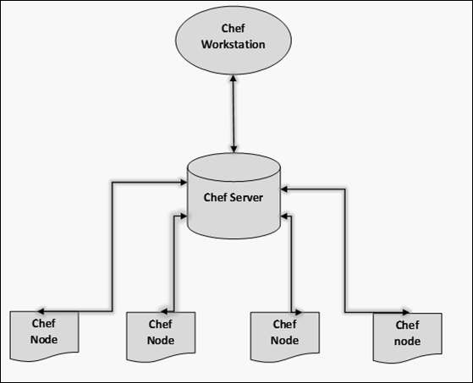

Workstation—it is computer code is written over here.

Chef server- all cookbooks are stored here. Server may be hosted locally or remote

Chef node- where we apply code

Codes are called recipe.

Cookbook- the folder where all the recipes are stored. Collection of recipe. Cookbook is stored in Chef server. Inside cookbook-

* Chefignore – like .gitignore
* Kitchen.yml- for testing cookbook
* Metadata.rb- name,version,author,etc of cookbook
* Reamdme.md – info ablout usage of cookbook
* Recipe – where you write code
* Spec – for unit test
* Test – for integration testing

Knife- the command line tool which pushes things from workstation to Chef server. Also it is used to connect server to nodes

Bootstrap- the process by which server connects to nodes

Chef-Supermarket- many types of recipe are available over here which can be reused.

Ohai- It fetches the current state of the node it is located in. Node communicate with chef-server using the chef-client. Chef client and Ohai are installed in every node.

Working of chef-client-

* Gather current system configuration
* Download the desired system configuration from chef server
* Configure the node such that the config in the chef server is present in chef node

Idempotency – tracking the state of system resources to ensure that the changes should not reapply repeatedly.

Ruby code—

Resource- basic component of recipe used to manage infrastructure. Types-

1. Package- manages package on node
2. Service
3. User
4. Group
5. Template – manages file with embedded ruby template
6. Cookbook-file – transfer the files from file subdirectory in the cookbook to a location on the node
7. File
8. Execute
9. Cron – edits existing cron file on node
10. Directory

Chef Attributes-

Attribute is a key-value pair which represents a specific detail about a node

Who uses attribute- chef client

Why we use attribute- To know-

* Current state of the node
* What the state of current node was at the end of previous chef-client run
* What the state should be after current chef-client run

Types of attribute in least to highest priority order-

* Default (least priority)
* Force_default
* Normal
* Override
* Force_override
* Automatic (highest priority)—it is only used by Ohai

Who defines attribute-

* Node (collected by Ohai at start of chef-client run)
* Cookbooks (via attributes file)
* Roles
* Environment
* Recipes

## attributes defined by Ohai have highest priority, then recipe’s attribute followed by attribute file’s attribute

ohai- running this command will display all the details of the machine in json format. To see specific info- ohai ipaddress

How to run linux command in the ruby script- In the recipe file-

This code will be run again and again when we hit chef-client unlike the ruby command

execute “run a script” do

command <<-EOH

mkdir /home/ec2-user/Amisha

touch /home/ec2-user/Amisha/test.txt

EOH

End

Runlist- it is the “recipe[xyz::abc]” in the chef-client cmd. Used to run the recipes in a particular sequence.

## We can run multiple recipe but condition is that we can run only 1 recipe from one cookbook. Eg- chef-client –zr “recipe[xyz::abc],recipe[pqr::wer]”

How to run more than 1 recipe from 1 cookbook at same time in a sequence?- use include recipe. Vi default recipe and write “include_recipe “cookbook_name::recipe1”” in it.

Setting up the client-server node model-

* Create an account on chef server
* Attach workstation with chef server
* Upload your cookbook from workstation to chef server
* Attach nodes to chef server via bootstrap process
* Apply cookbooks from chef server

For setting up chef-server and connecting workstation to it–

* Create account on manage.chef.io
* Go to chef account->click on organization -> starter kit -> download starter kit
* Open the downloaded content 🡪 chef-repo
* Copy this chef-repo to your machine wherever workspace is setup
* Inside chef.repo we have 3 file-
  + .chef –it consists of config.rb(contains config of chef server) and a pem file
  + Cookbooks- all work has to done here
  + Role-
* To check if the machine is connected to chef server- knife ssl check

For setting up node and connecting it to chef server-

Attaching a node to chef server is called bootstrapping. Both workstation and node should be in same AZ. Two actions are done while bootstrapping- adding node to chef server –installing chef package

Steps-

* Create a linux machine
* Go to chef workstation
* Hit the command- knife bootstrap <private_ip_of_node> --ssh-user ec2-user --sudo –i node-key.pem –N node1 (before this paste node-key.pem or key used to launch node to chef-repo in workstation)
* To see bootstrapped nodes- knife node list

To upload cookbook in workstation to chef-server and run recipe on node-

* Knife cookbook upload test-cookbook
* Now check whether the cookbook got uploaded or not
* Or use- knife cookbook list
* Now to run recipe on node – knife node run_list set node1 “recipe[cookbook_name::recipe_name]”
* To view – knife node show node1 – this shows the list of recipe which has been attached to node1 so whenever a change happens in recipe node1 will get automatically updated
* Now login to chef node and run command – chef-client

Now lets automate this process-

* Login to node
* vi /etc/crontab

***** root chef-client --- this means every min it will check with chef-server for updates

* now go to chef-workstation
* Make change in the recipe of cookbook registered with node
* Save it and upload to chef-server
* Now check if the node got updated or not

Commands to delete and clean chef server-

To delete cookbook from chef-server- knife cookbook delete <cookbook_name> –y

To delete nodes from chef-server- knife node delete <node_name> -y

To delete client from chef server – knife client delete <client_name> -y

To delete role from chef server- knife role delete <role_name> -y